Spectral Estimation
7.1 Power Spectral Density Estimation and Spectral Analysis of Noisy Sinusoidal Signals Using Periodogram Method in MATLAB
Program (MATLAB Code)
clc; clear; close all
fs=1000; t=(0:999)/fs;
s=sin(2*pi*100*t)+0.5*sin(2*pi*200*t);
n=0.3*randn(size(t));
x=s+n;
figure, plot(x), grid on
title('Signal with Noise')
figure, periodogram(x,[],[],fs)
title('PSD using Periodogram')
figure
X=abs(fft(x));
f=(0:length(X)-1)*fs/length(X);
plot(f(1:500),X(1:500)), grid on
title('Magnitude Spectrum')
figure
bar([mean(s.^2) var(n)])
set(gca,'XTickLabel',{'Signal','Noise'})
title('Power Comparison')
grid on

Output
Fig 1
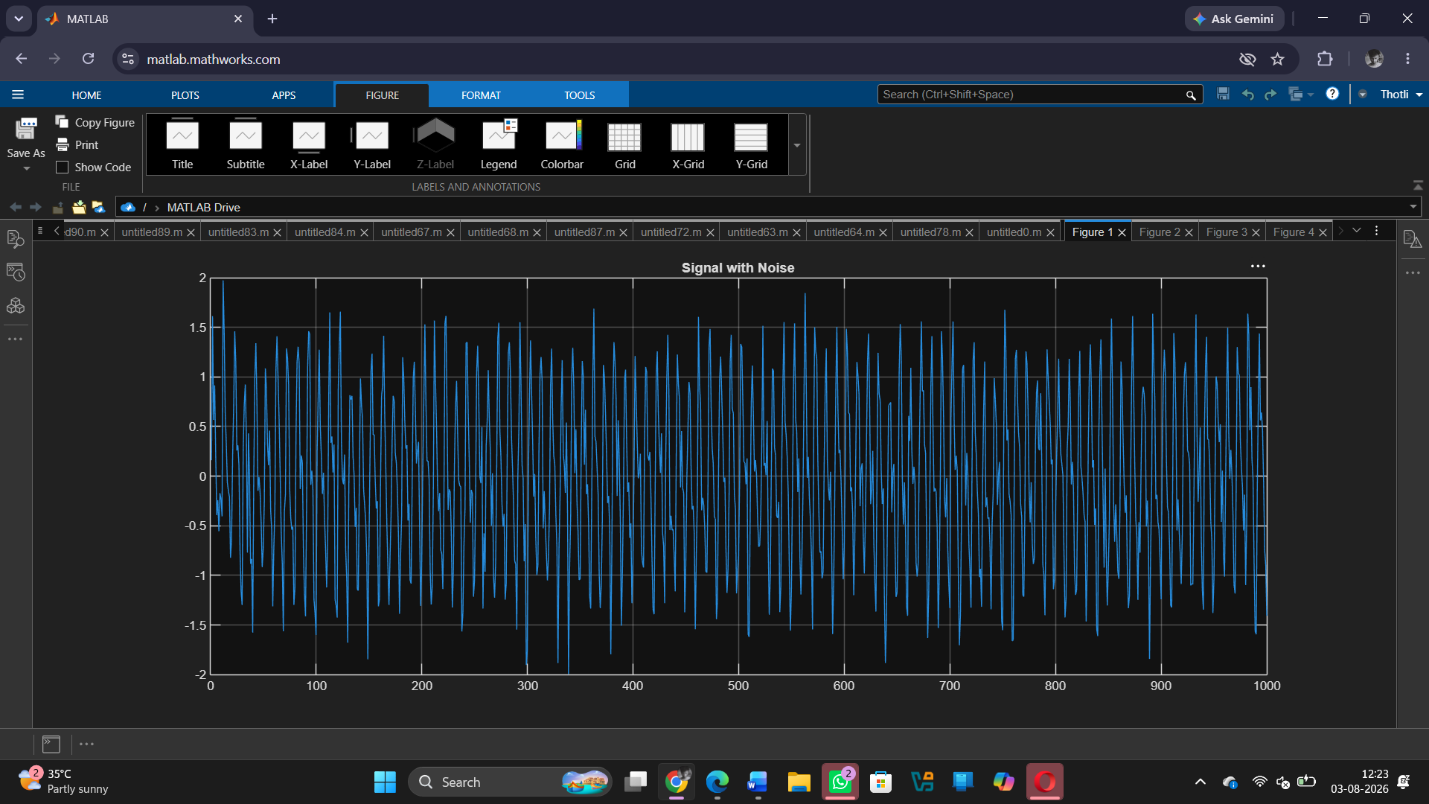

Fig 2
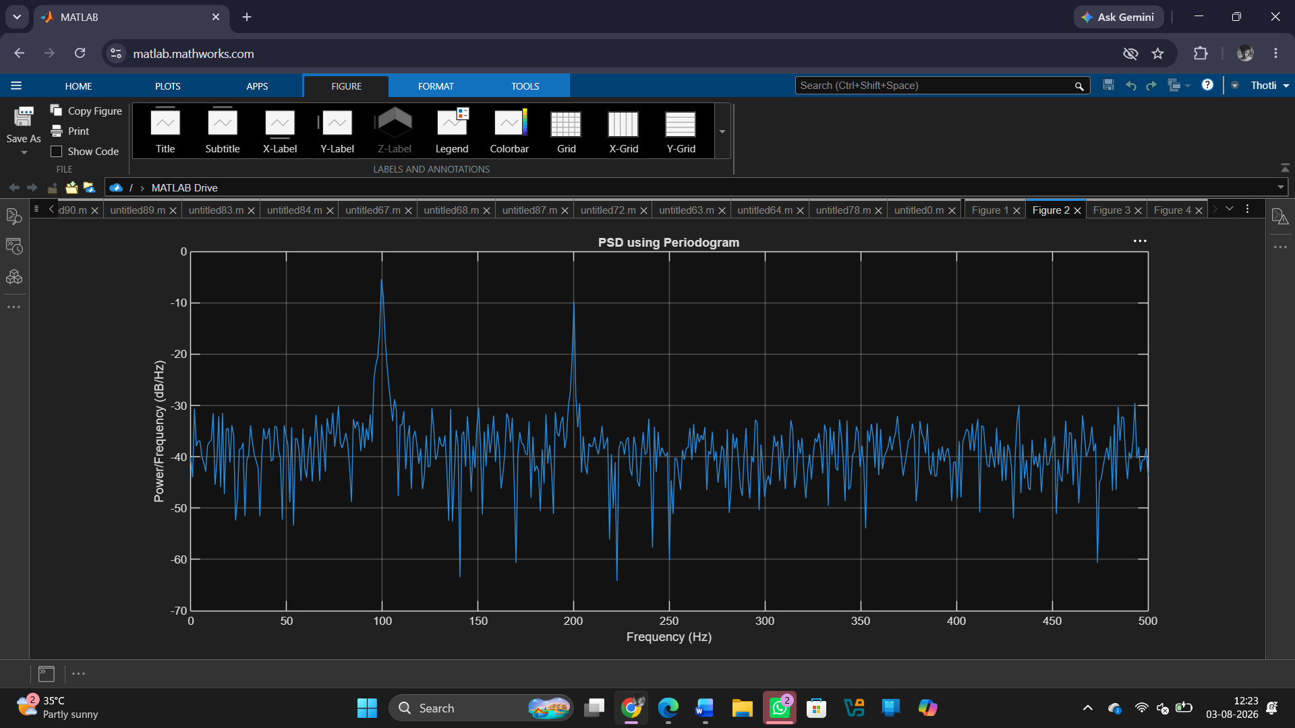

Fig 3
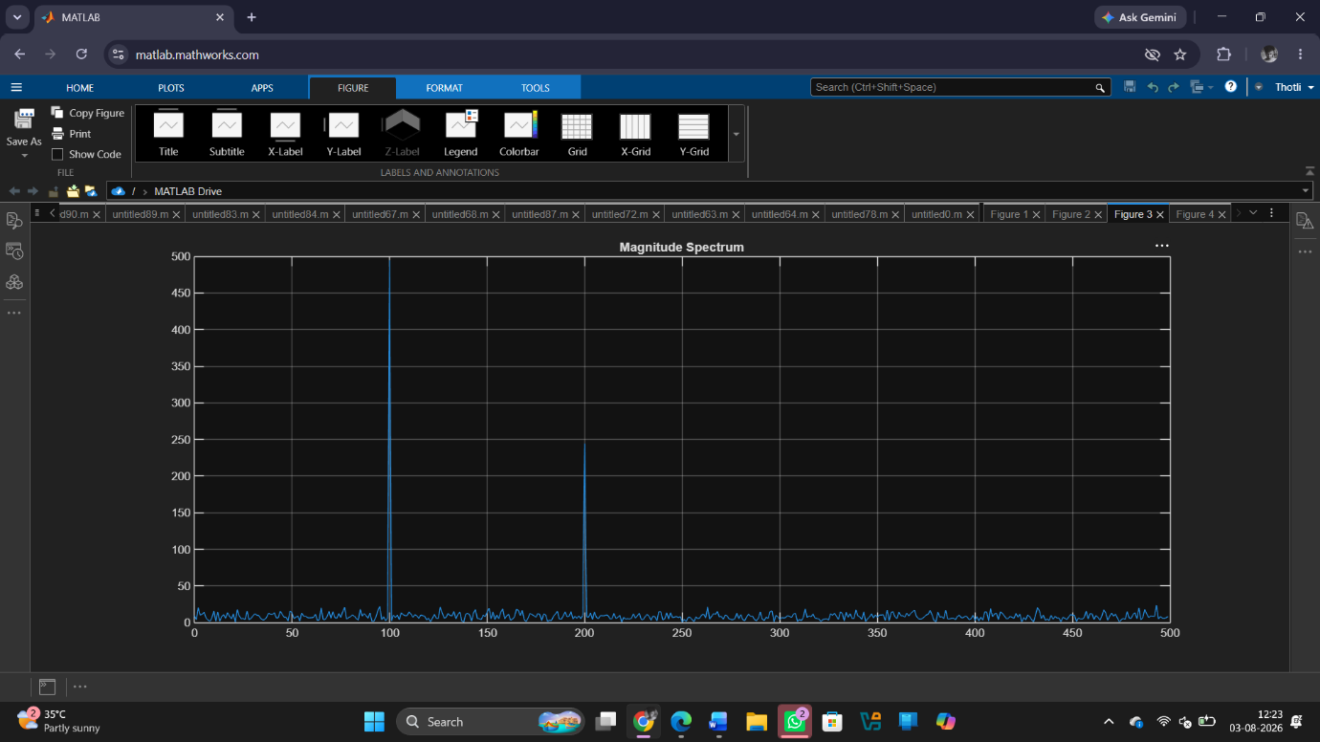

Fig 4
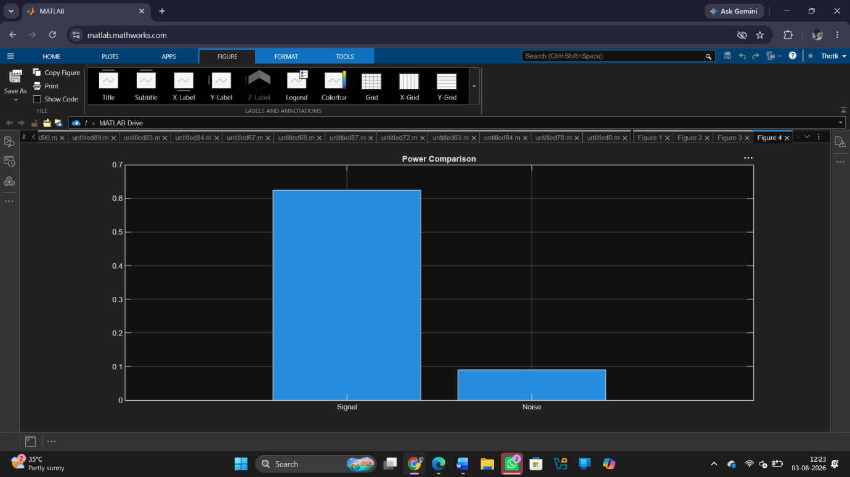

Result
1. A discrete-time signal consisting of sinusoidal components with added noise was successfully generated in MATLAB.
2. The Power Spectral Density (PSD) of the signal was estimated using the Periodogram method.
3. The dominant frequency components present in the signal were accurately identified from the PSD plot.
4. The spectral characteristics of the signal were analysed, showing the distribution of signal power across frequencies and the effect of noise on the spectrum.

